[HiNAS Control Standard Onboard Test Procedure]

Avikus
Accept by:
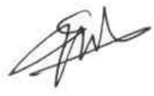
Tested by: Seunghyun Woo
Avikus
Date : 2026.04.13


[ Revision History ]
Documents Number. | Revision Number. | Revision Date | Description
AVK-NAS-CTRLSTD-0040 | 1.0.0 | 2025-03-30 | Draft
AVK-NAS-CTRLSTD-0040 | 1.0.1 | 2025-03-30 | Added expected result
AVK-NAS-CTRLSTD-0040 | 1.0.2 | 2025-11-20 | 3.4 Autopilot fail test revised

[ Operator Information ]
Operator | Position | Name | Signature
- | manager | Seunghyun Woo

[ Caution ]
AVIKUS PROPRIETARY DATA
This document contains confidential proprietary information.
Restricted to use only by Avikus employees or other persons authorized by Avikus in writing to use it.
Since it contains Avikus trade secrets, you cannot view, use, copy, distribute, or disclose this material without the prior written approval of Avikus.

Contents
1. Wiring Diagram (Should be changed as per the ship specifications) 4
2. Check list for Testing 5
2.1 Performance Tests 5
3. Test Contents & Procedure 6
3.1 System Health Check Test 6
3.2 Basic Functionality Test 7
3.3 Route Planning Test 10
3.4 Autopilot fail test 15
3.5 Sensor interface fail test 17
3.6 BMS Fail Test 22
3.7 Power Fail Test 23
3.8 Operation Mode Change Test – Mode Selection Unit 25
3.9 Operation Mode Change Test – SW Button 26

- 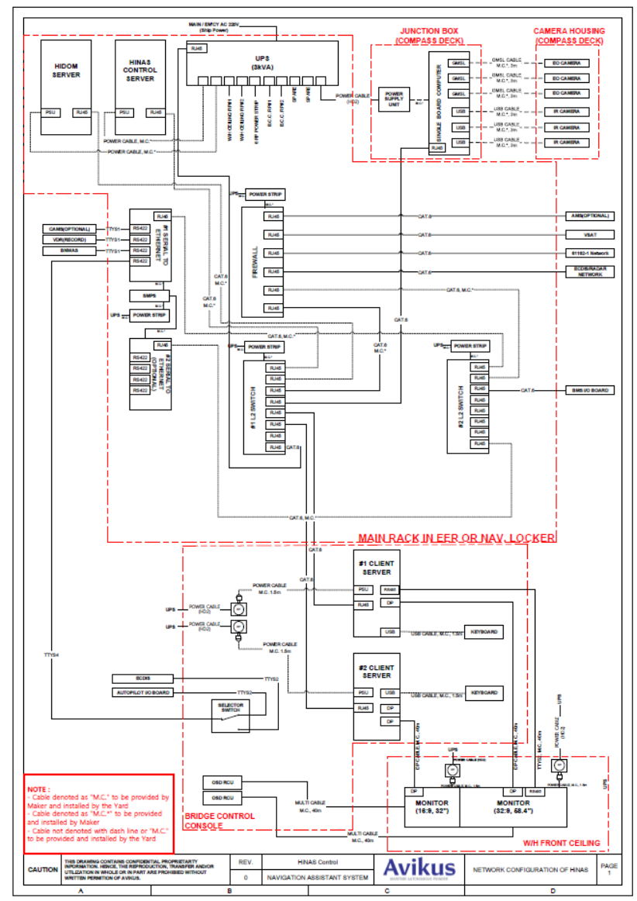Wiring Diagram (Should be changed as per the ship specifications)

- Check list for Testing
  - Performance Tests
No | Article | Contents | No | Article | Contents
1 | - | System health check test | 6 | IEC62065  - | BMS fail test
2 | - | Basic functionality test | 7 | IEC62065  5.1.3.1 | Power fail test
3 | - | Route planning test | 8 | - | Operation mode change test – Mode selection unit
4 | IEC62065  5.1.1.14  5.5.1 | Autopilot fail test | 9 | - | Operation mode change test – SW Button
5 | IEC62065  5.1.3.2  5.1.3.4  5.5.2~5.5.4 | Sensor interfaces fail test

- Test Contents & Procedure
  - System Health Check Test
Relevant Standard | Standard No.
 | Article.
Purpose | The purpose of this test is to check the hardware equipment before actual test
Procedure of test |  | Pass | Fail
- Visual inspection items below.  - Steering unit (Auto pilot) is installed on ship  - Speed control unit (BMS) is installed on ship  - Route sender (ECDIS) is installed on ship  - HiNAS Control Standard is installed on ship |  | v
Comment / Recommended

  - Basic Functionality Test
Relevant Standard | Standard No. (MSC Circ.982)
 | Article.
Purpose | The purpose of this test is to evaluate display function of HiNAS Control Standard in normal condition performance
Procedure of test |  | Pass | Fail
- Execute the HiNAS Control Standard product in apps page  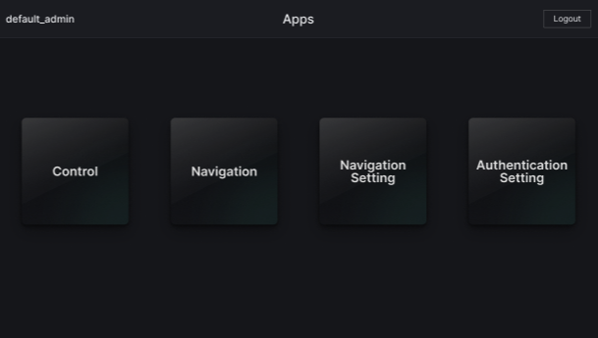  - Test zoom in/out function and see if map display scale is changed as per the control  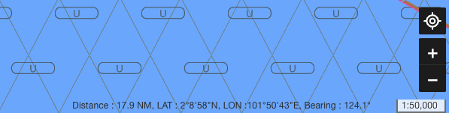  - Test display mode change function and see if display mode (Day, Night)/ (map only, camera only, both) / (Brightness) is changed as per the control    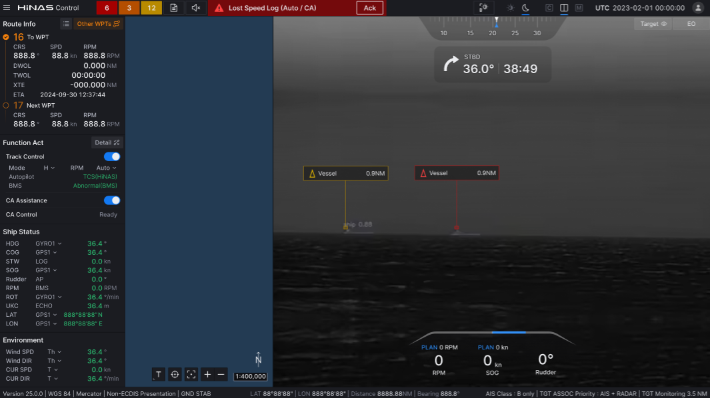  * Note: Camera and map view may vary with external environment  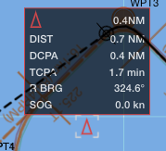  * Note: Target information may vary with external environment |  | v
Comment / Recommended

  - Route Planning Test
Relevant Standard
Purpose | The purpose of this test to evaluate route planning API performance (no weather condition) and to evaluate route planning API interface performance
Procedure of test |  | Pass | Fail
- Plan any dummy route in ECDIS and activate route monitoring function of ECDIS  - Open route planning – from ECDIS in HiNAS Control Standard  - Set departure time as now, and arrival time as certain time  - Calculate voyage optimization  5. Check if the latitude and longitude coordinates of the Applied Route from the EUT match those of the Route data from the ECDIS  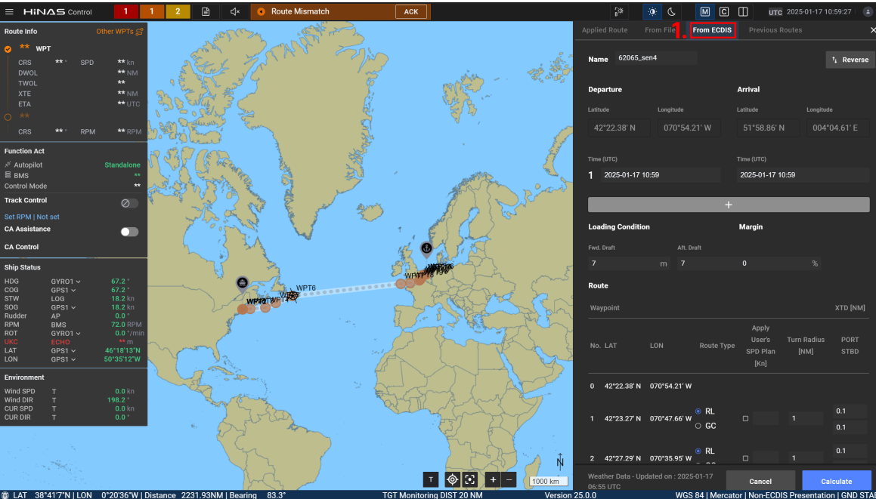  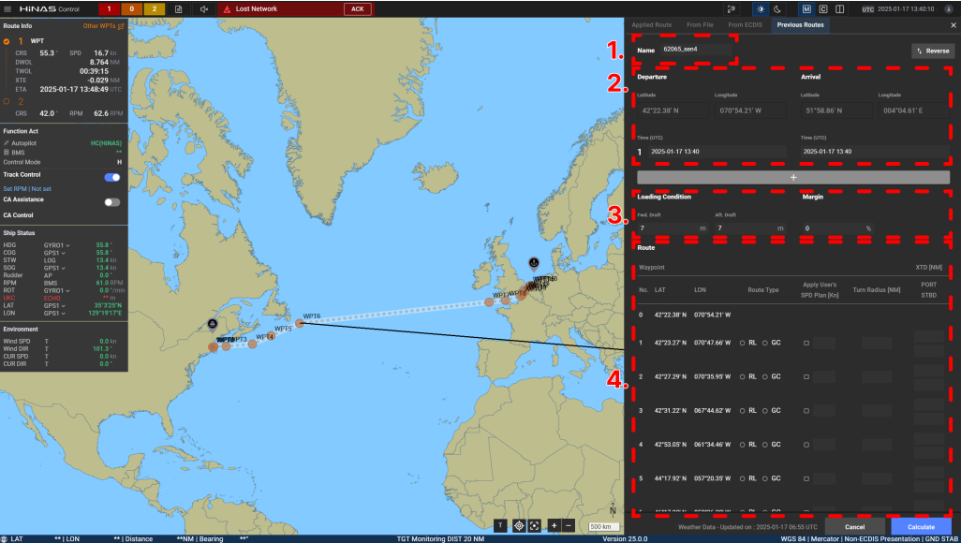  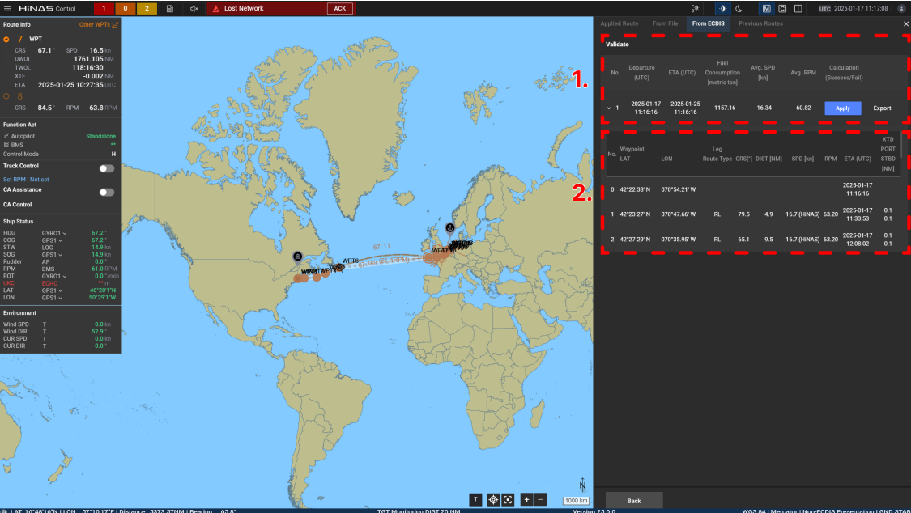  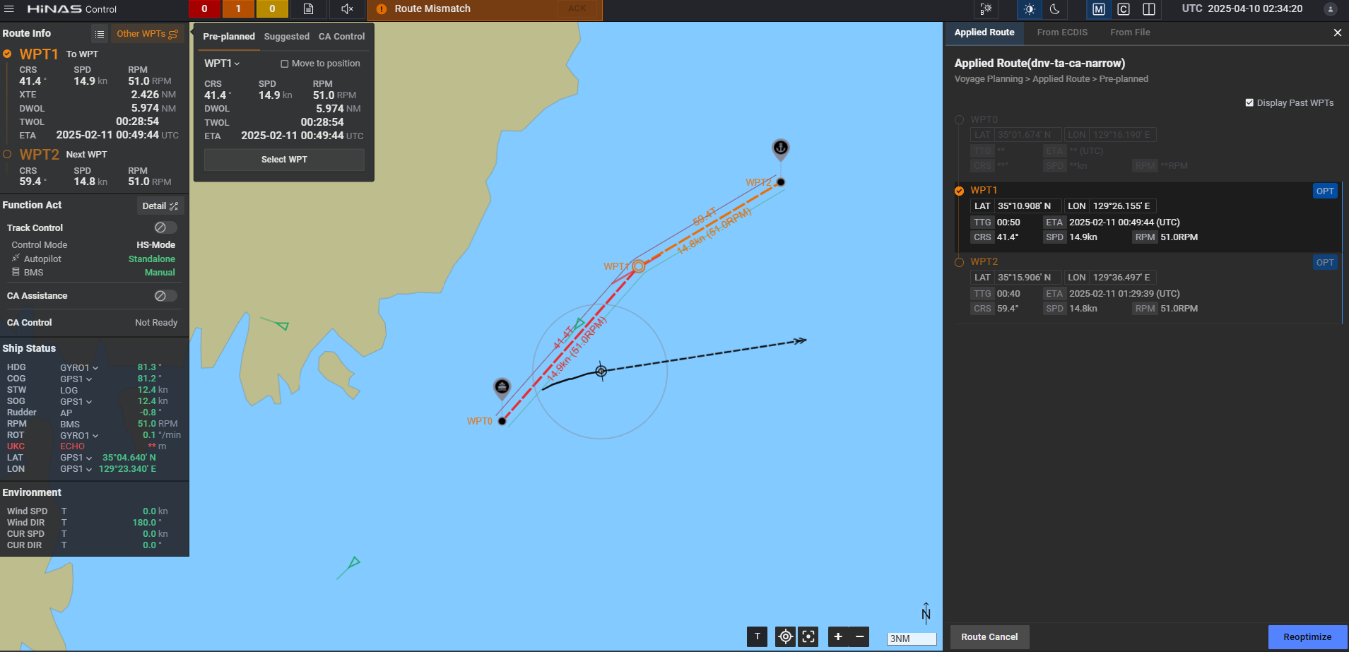  <6. Confirm Applied Route > |  | v
Comment / Recommended

  - Autopilot fail test
Relevant Standard | Standard No. IEC62065
 | Article. 5.1.1.14 and 5.5.1
Purpose | The purpose of this test is to evaluate alarm status information performance test when certain interface is disconnected and to check the alarm level is correspondence with design requirement
Procedure of test |  | Pass | Fail
- Ensure that the Autopilot firmware version meets the specifications defined in MED-B before proceeding with the test.  - Prepare HiNAS Control Standard voyage planning and autopilot as normal condition, ensure autopilot will not affect the rudder.  - Press TC button of HiNAS Control Standard  - Change manual steering mode to heading control mode of autopilot  - (TKM) Press Ext.HC of Autopilot  - Disconnect autopilot by  - Turning "mode selection unit" to "ECDIS" or "OFF"  - If the ECDIS equipment is equipped with a Track Control function, indicate “ECDIS” on the switch when the NAS device is disconnected.  - If the ECDIS equipment is not equipped with a Track Control function, indicate “OFF” on the switch when the NAS device is disconnected.  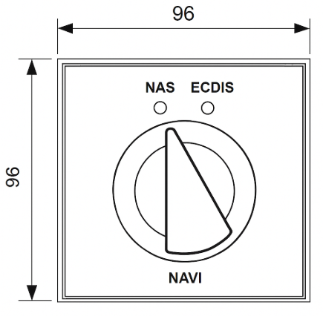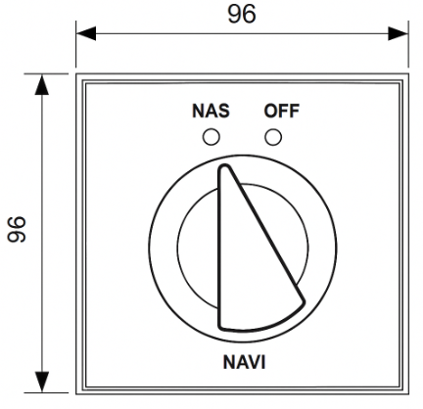  - Verify the following:  - 'Track control stopped' or its equivalent alert is raised in alert list with buzzer sound.  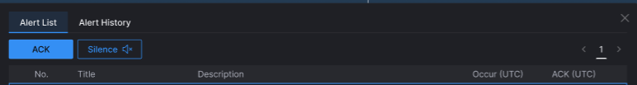  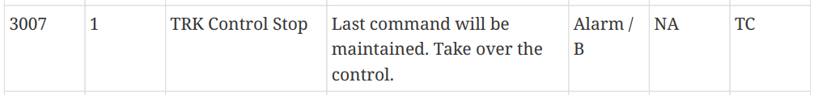  * Note: Alert list page may vary with ship condition |  | v
Comment / Recommended

  - Sensor interface fail test
Relevant Standard | Standard No. IEC62065
 | Article. 5.1.3.2, 5.1.3.3, 5.5.2, 5.5.3, 5.5.4
Purpose | The purpose of this test is to evaluate alarm status information performance test when certain interface is disconnected and to check the alarm level is correspondence with design requirement
Procedure of test |  | Pass | Fail
- Same procedure of 1~4 of 3.4.  - Disconnect all connection to sensors  - Verify following  - ‘Lost Network’ or its equivalent alert is raised in alert list    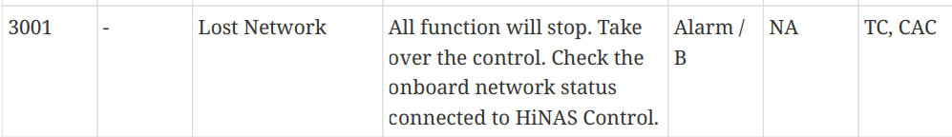  * Note: Alert list page may vary with ship condition  - Same procedure of 1  - Disconnect position sensor  - Verify following  - ‘Lost Position’ or its equivalent alert is raised in alert list  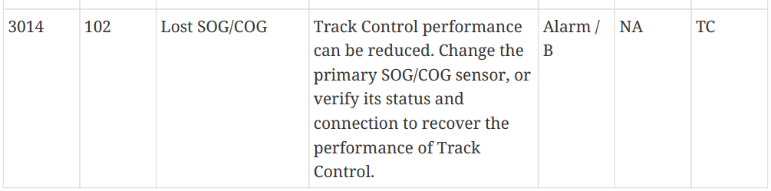  - Same procedure of 1  - Disconnect heading sensor  - Verify following  - ‘Lost Heading’ or its equivalent alert is raised in alert list  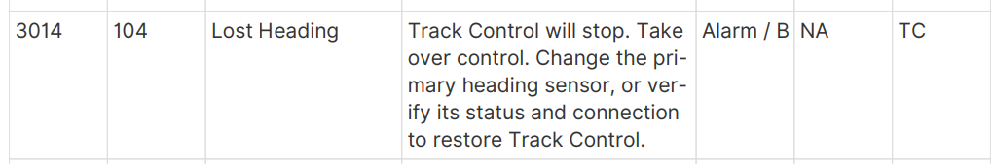  - Same procedure of 1  - Disconnect speed sensor  - Verify following  - ‘Lost STW’ or its equivalent alert is raised in alert list  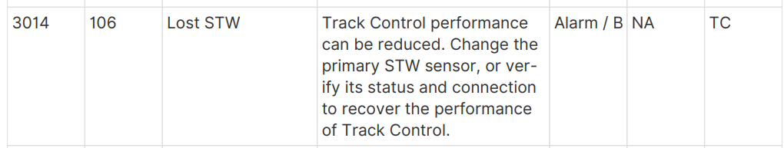  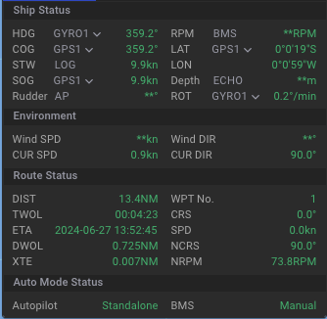  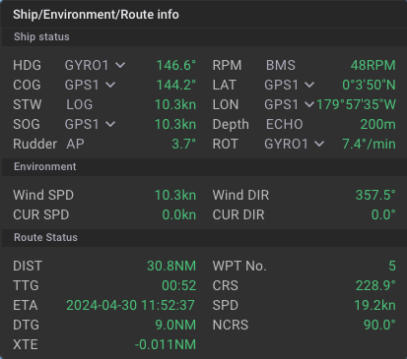  * Note: Signal lost can be found in below status display |  | v
Comment / Recommended

  - BMS Fail Test
Relevant Standard
Purpose | The purpose of this test is to evaluate alarm status information performance test when certain interface is disconnected and to check the alarm level is correspondence with design requirement
Procedure of test |  | Pass | Fail
- Ensure BMS is turned on  - Disconnect BMS interface cable  - Verify following  - BMS status in HiNAS Control Standard is changed to “**”  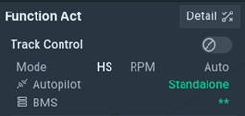  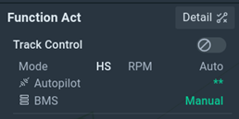 |  | v
Comment / Recommended

  - Power Fail Test
Relevant Standard | Standard No. IEC62065
 | Article 5.1.3.1.
Purpose | The purpose of this test is to evaluate alarm status information performance test when certain interface is disconnected and to check the alarm level is correspondence with design requirement
Procedure of test |  | Pass | Fail
- Remove power from the UPS of HiNAS Control Standard  - Verify following  - ‘Power fail’ or its equivalent alert is raised in alert list  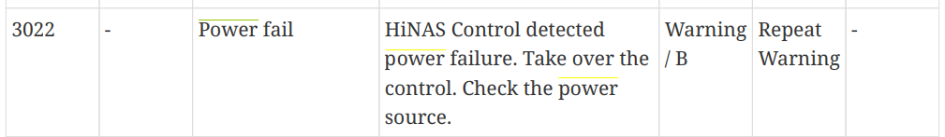  - ‘Lan fail’ alert is raised in alert list  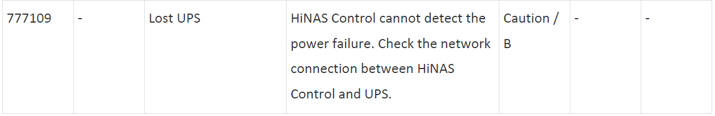 |  | v
Comment / Recommended

  - Operation Mode Change Test – Mode Selection Unit
Relevant Standard | Standard No.
 | Article
Purpose | The purpose of this test is to test auto pilot mode is changed to stand-alone mode after HiNAS mode change
Procedure of test |  | Pass | Fail
- Mode change by mode selection unit.  - Common for test item 3.4 |  | v
Comment / Recommended

  - Operation Mode Change Test – SW Button
Relevant Standard | Standard No.
 | Article
Purpose | The purpose of this test is to test auto pilot mode is changed to stand-alone mode after HiNAS mode change
Procedure of test |  | Pass | Fail
- Same procedure of 1~4 of 3.4.  - Deactivate Track Control function of HiNAS (SW button)  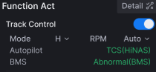  - Verify following  - Operation mode of Autopilot is changed to HC(or equivalent mode) mode |  | v
Comment / Recommended

